**DAILY ONLINE ACTIVITIES SUMMARY**

|  |  |  |  |  |  |  |  |
| --- | --- | --- | --- | --- | --- | --- | --- |
| **Date:** | **23-05-2020** | | | | **Name:** | **Gudugunti Anirudh** | |
| **Sem & Sec** | **IV - A** | | | | **USN:** | **4al18cs023** | |
| **Online Test Summary** | | | | | | | |
| **Subject** | | **Data Communication** | | | | | |
| **Max. Marks** | | **30** | | **Score** | | **26** | |
| **Certification Course Summary** | | | | | | | |
| **Course** | **Python in ML** | | | | | | |
| **Certificate Provider** | | | **Great learning academy** | **Duration** | | | **2hrs** |
| **Coding Challenges** | | | | | | | |
| **Problem Statement:** 1. Triangular numbers.  2. Find the product. | | | | | | | |
| **Status: Uploaded** | | | | | | | |
| **Uploaded the report in Github** | | | | **Yes** | | | |
| **If yes Repository name** | | | | **https://github.com/Anirudh23-23/Daily-progress** | | | |
| **Uploaded the report in slack** | | | | **Yes** | | | |

Online Test Details: The online test was from module 1 and module 2 which was about the introduction to data communication, about network models, digital transmission, analog transmission and introduction to physical layer. There were 30 questions and the duration were 40 minutes. The questions were optimal and were easy. The score that I got in the test is 26/30.

Snapshot:

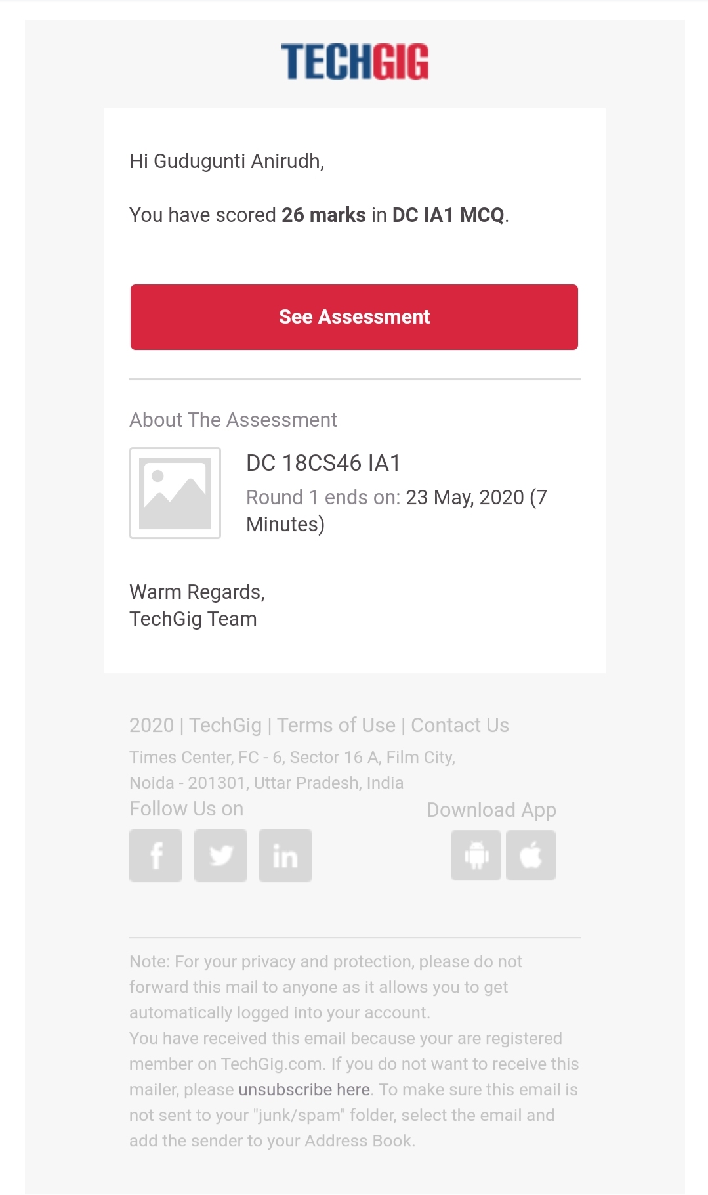

Certification Course Details:

1. Loops in python.

2. Detailed instructions on Loops of python.

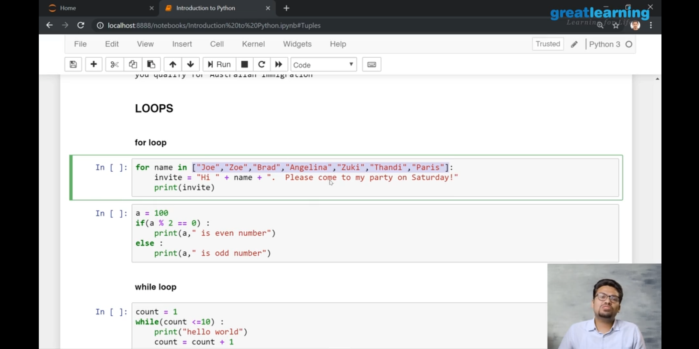

3. Instructions on Loops like: for,while,do-while.

Coding Challenges Details:

Problem 1: (using C language) Write a program to print n triangular numbers.

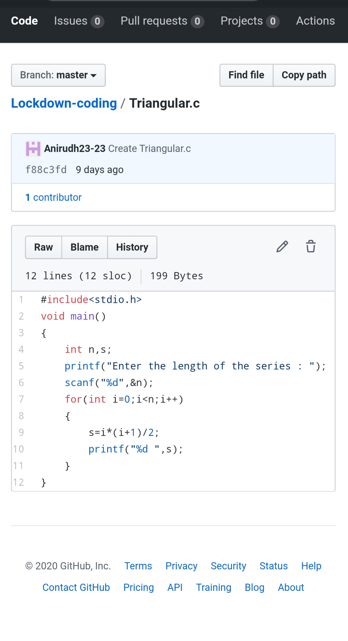

Problem 2: (Using python) Write a program to find the product.

